Sinhgad Technical Education Society,  Sinhgad College of Engineering , Pune-41  Department of Computer Engineering | 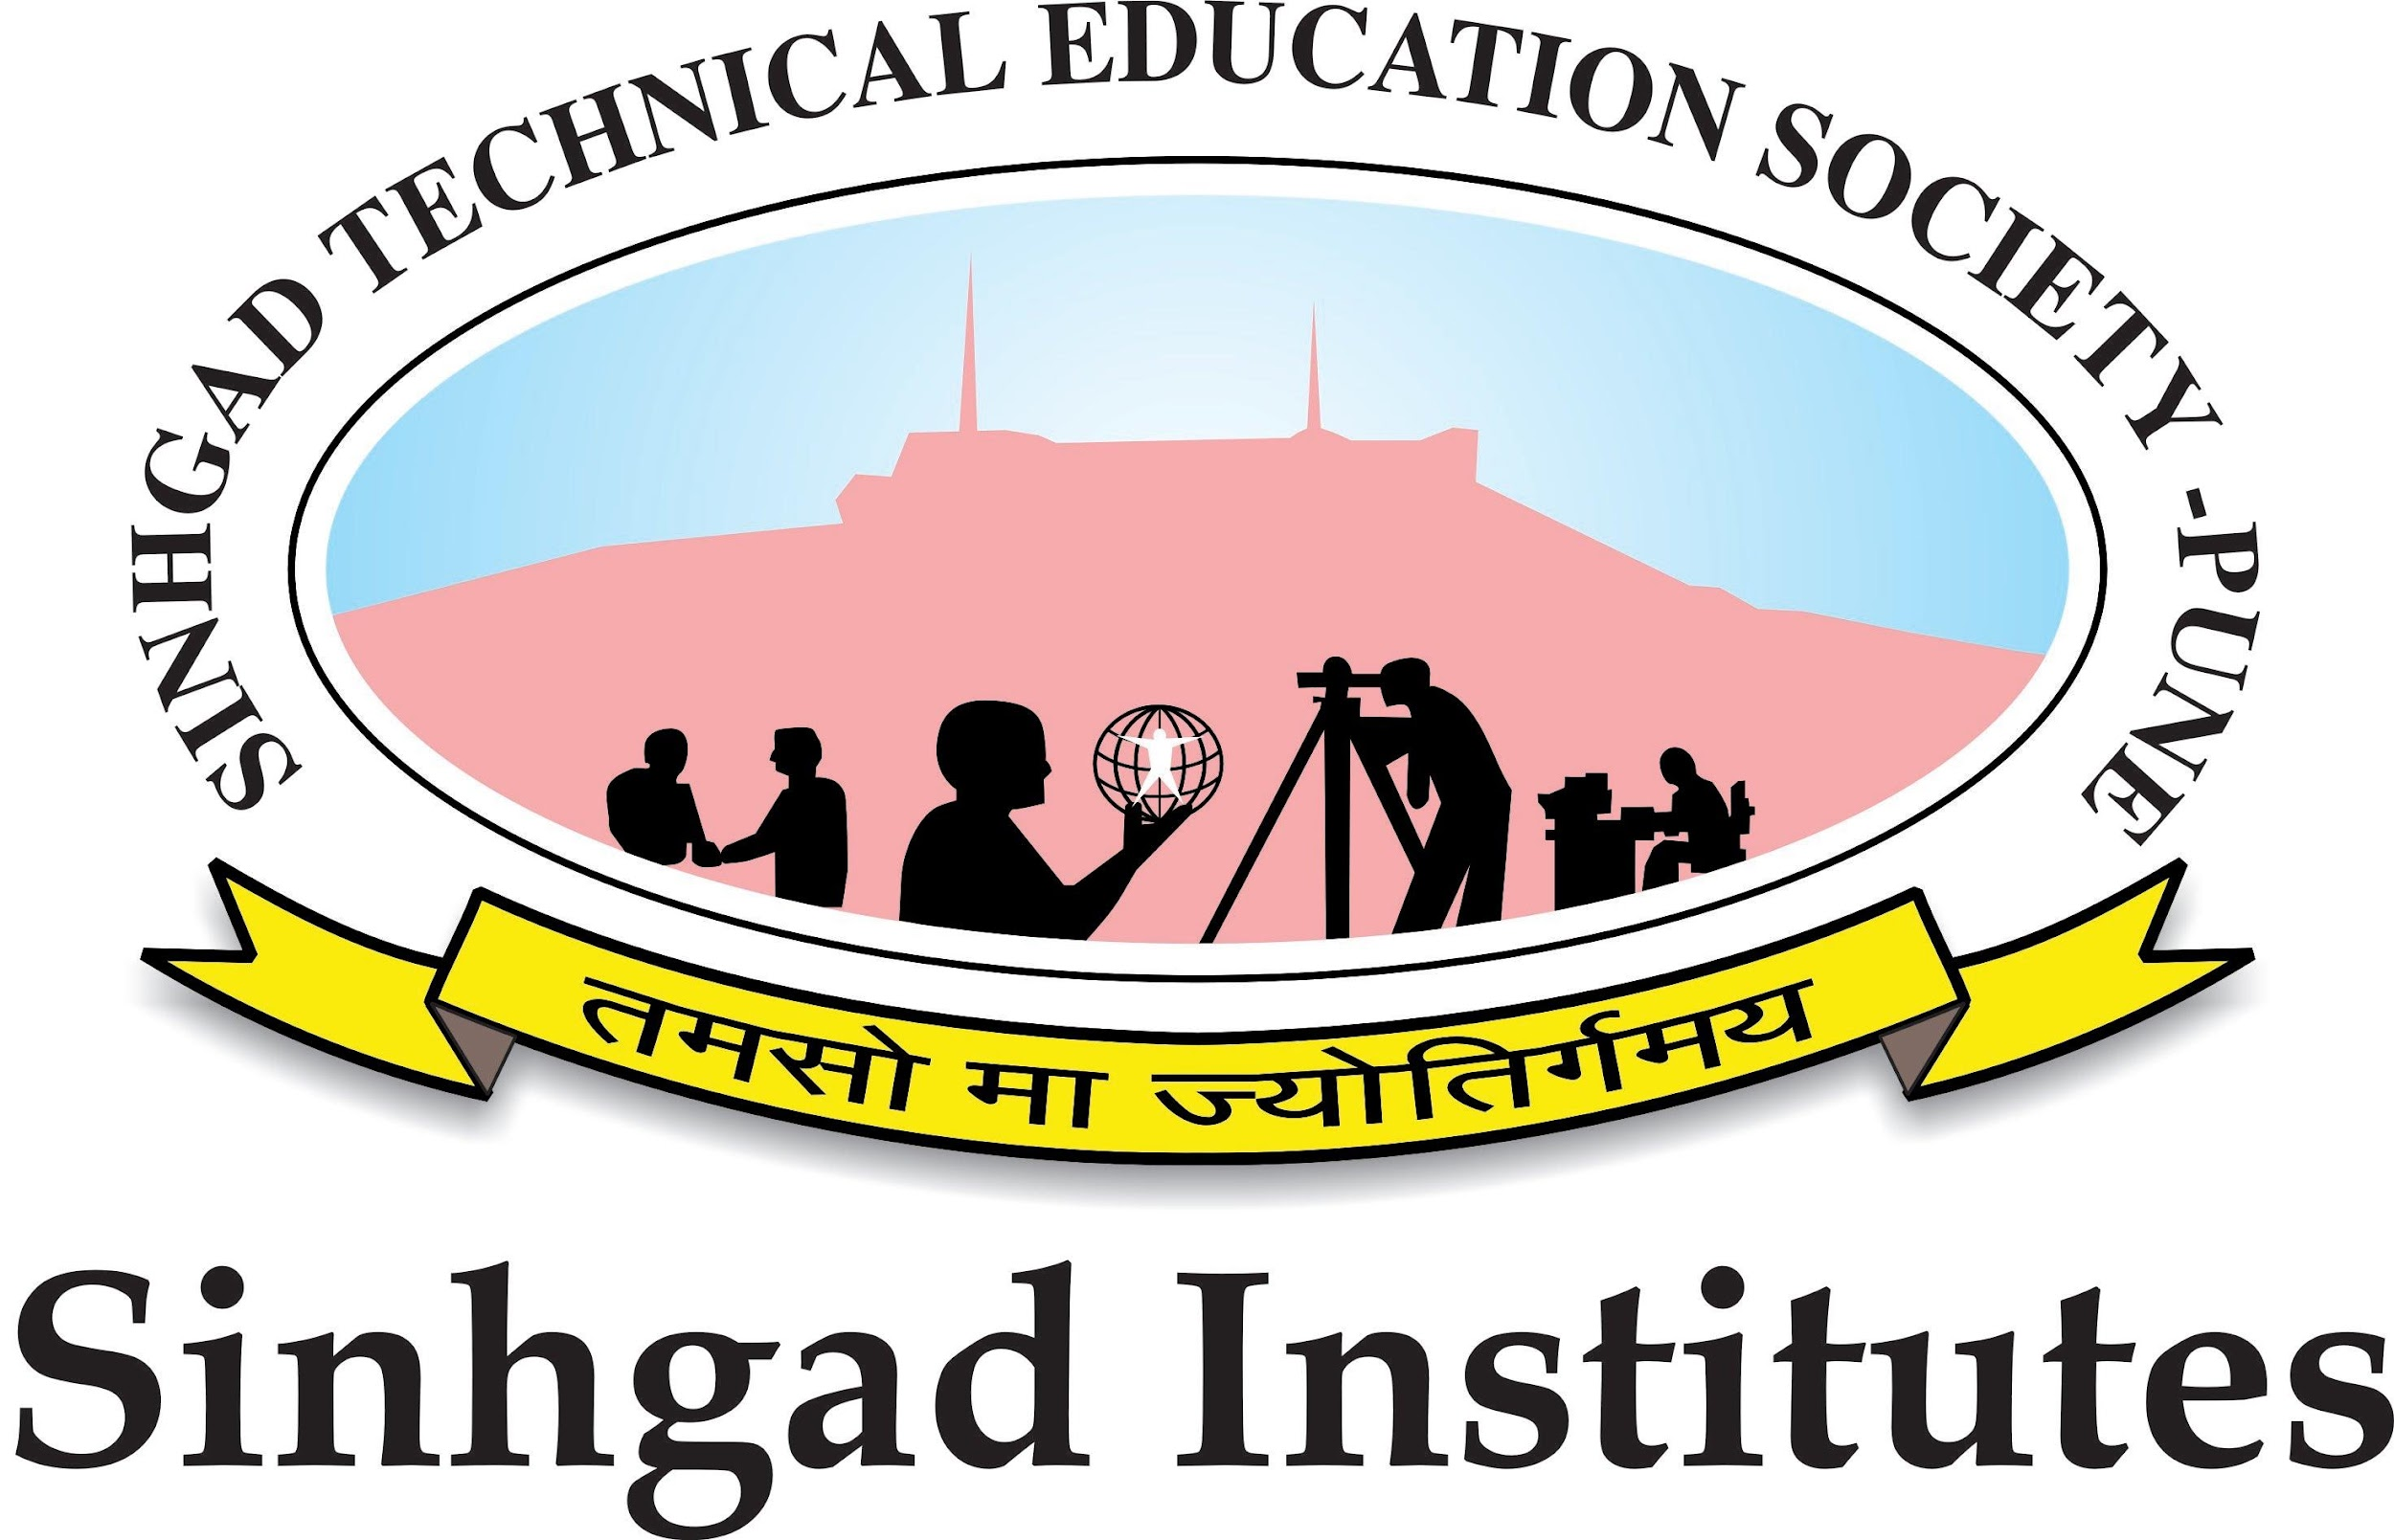
Date:
CERTIFICATE
This is to certify that the preliminary project report entitled

VIDHAN : A GAMIFIED APPROACH TO LEARNING THE INDIAN CONSTITUTION WITH AI ASSISTANCE
Submitted by

YASHKUMAR SHAMKANT PATIL PRN No: 72231439G

DHANASHREE SANJAY LOMTE PRN No: 72308274L

TEJAS KAILAS PATIL PRN No: 72231433H

ADITI AMBADAS KHEDKAR PRN No: 72308261J

is a bonafide work carried out by them under the supervision of Prof. R. A.Vasmatkar and it is approved for the partial fulfillment of the requirements of Savitribai Phule Pune University, Pune for the award of the degree of Bachelor of Engineering (Computer Engineering) during the year 2025-26.

Prof R.A.Vasmatkar Dr. R. H. Borhade
Guide Head, Computer Engineering
Department of Computer Engineering & Vice Principal, SCOE

Dr. S. D. Lokhande
Principal
Sinhgad College of Engineering

